|  |  |  |  |  |
| --- | --- | --- | --- | --- |
| To: | | | Council | |
| Date: | | | 20th March 2023 | |
| Report of: | | | Head of Regeneration and Economy | |
| Title of Report: | | | Partnership Update – Oxfordshire Local Enterprise Partnership | |
| Summary and recommendations | | | | |
| Purpose of report: | | | To provide members with an update on the work of Oxfordshire Local Enterprise Partnership (OXLEP). | |
| Key decision: | | | No | |
| Cabinet Member with responsibility: | | | Cllr Susan Brown, Leader of Oxford City Council and Economic Development Portfolio holder | |
| Corporate Priority: | | | Fostering an Inclusive Economy | |
| Policy Framework: | | | Economic Development Strategy | |
| Recommendation(s):That the Committee resolves to: | | | | |
| 1. | **The Council is invited to comment and note the report.** | | | |

|  |  |
| --- | --- |
| Appendices | |
| Appendix 1 | N/A |

# Introduction and background

1. Oxfordshire Local Enterprise Partnership Ltd (OxLEP) is the over-arching local partnership promoting economic growth and shaping the strategic direction of the Oxfordshire economy. Chief Executive, Nigel Tipple leads a team of staff who work closely with a network of business representatives, further and higher education representatives, state secondary schools/colleges and Economic Development officers. OxLEP are a key stakeholder supporting the Oxfordshire ‘Whole System’ (Local Authorities and Public Health) and also are members of the Future Oxfordshire Partnership.
2. Jeremy Long, appointed as Board Chair in March 2016, stands down this year, having helped position the importance of Oxford Station and the Inclusive Economy agenda alongside the OSP and City Council. From March 2023 Professor Alistair Fitt, Pro-Vice Chancellor at Oxford Brookes University takes the OxLEP chair.
3. Cllr Susan Brown is the City Council’s OXLEP Board member, alongside the other council leaders across the county. Peter Nolan, formerly of Oxford BioMedica sits on the OXLEP Board and chairs the Oxford Economic Growth Board (sub group of Oxford Strategic Partnership, on both of which Cllr Susan Brown also sits), providing a direct link between the city’s interests and the wider OXLEP area. Phil Southall, Bus Performance Director of Go-Ahead Group, and Penny Rinta-Suksi, Partner at Blake Morgan are also current Oxford based members of the Board
4. Officers are involved in a range of OXLEP partnerships, and OxLEP colleagues are involved in many city and district partnerships. There is ongoing officer involvement through Directors, Regeneration & Economy, Planning, Sustainability and Welfare Reform. OxLEP’s Governance and Reporting Structure is below:

**LEP Review**

1. HMG published the outcome of the LEP review in March 2022. Government is encouraging the integration of LEPs and their business boards into Mayoral Combined Authorities and County Deals, where these exist. Where a devolution deal does not yet exist, LEPs will continue to play a key role. HMG expect the future role of LEPs – or the local democratic institution after LEP functions have been integrated – will be to:
   1. Embed a strong, independent and diverse local business voice into local democratic institutions.
   2. Carry out strategic economic planning in partnership with local leaders that clearly articulates their area’s economic priorities and sectoral strengths. This should involve building and maintaining a robust local evidence base that identifies local strengths and challenges, future opportunities and the actions needed to support priority sectors, aligned to the relevant levelling up missions.
   3. Continue to deliver a number of functions on behalf of government departments, shaped by the local business voice where relevant- including;
      1. Growth Hubs (business support service), on behalf of the Department for Business, Energy and Industrial Strategy;
      2. International trade and investment activity on behalf of the Department for International Trade;
      3. Local Digital Skills Partnerships, on behalf of the Department for Digital, Culture, Media and Sport;
      4. Careers Hubs, on behalf of the Department for Education;
      5. Local skills analysis via Skills Advisory Panels, on behalf of the Department for Education; and
      6. Monitoring and assurance pertaining to existing local growth programmes and funds for which LEPs are responsible.
      7. Where appropriate, LEP business boards can help broker and support new or deeper devolution deals, where requested by local partners.

**Governance**

1. All LEPs must adhere to a National Assurance Framework, ensuring robust systems and processes are in place. This ensures they are equipped to develop their Local Assurance Framework. Oversight and scrutiny of this assurance framework is undertaken by the County Council’s Section 151 Officer, whose role it is to sign-off and certify each year. This is assessed by annual performance review with central government with no concerns highlighted.

**OxLEP Impact**

1. The OxLEP Annual Report 21-22 highlights some of the notable impacts of its activity;
   1. 1,500 businesses supported, 1,300 business action plans provided through the new LEP business support tool and 100+ business support webinars delivered
   2. Delivered c£2.1m Business Resilience Grant Funding to businesses
   3. Launched the £1.7m Social Contract Programme – aimed at supporting those most impacted by the pandemic with new skills and training and the £1.7m Visitor Economy Renaissance Programme (VERP)
   4. Supported 52 secondary schools and colleges’ delivery of Gatesby Benchmarks – a framework that sets out what world class careers provision in education looks like and provide a clear framework for its delivery.
   5. Foreign Direct Investment Targets met (see below)

**Strategy and Funding**

1. Aligned to its strategic economic planning function described in the LEP review, OxLEP is leading the development of a new economic strategy for Oxfordshire. Recognising that much has changed since the last substantive economic assessment (the Local Industrial Strategy 2019), OxLEP is leading a cross sector partnership that will assess our post pandemic economy and provide the most current economic data and projections available to help shape future priorities.

The Oxfordshire Economic Recovery Plan (ERP – see background documents) was developed by the LEP, councils, universities and its various groupings in response to the pandemic, as requested by Government. It provides a ‘route map’ for economic recovery, focusing on Oxfordshire’s People, Places and Businesses running from spring 2021 through to spring 2023.

The ERP was also positioned as a basis for future proposals to Government under the UK Shared Prosperity Fund, the Levelling-Up Fund, innovation investment through the UK R&D Roadmap and funding in support of connectivity projects via DfT and DCMS. The ERP has been a catalyst for a range of locally led actions and a number of its projects are underway, regardless of national funds. The Social Contract, Business Resilience and VERP programmes listed above directly align to ERP priorities. The ERP is overseen by the Economic Recovery Task Group, with senior city council officer representation.

OxLEP is actively pursuing its ambitions and many of those in Oxford’s Economic Strategy, which builds on the ambitions and projects in the LIS. The ambition for the LIS is to position the county as a world-leading science and technology cluster and to be a pioneer for the UK and our emerging transformative technologies and sectors. It also contains a commitment to inclusive, low carbon growth. Key council projects highlighted in the Investment Plan include, the West End, he Inclusive Economy Commission (now Partnership), creative and flexible workspaces including Standingford House and George St, funded, Oxford Station and Cowley Branch Line (Oxfordshire Connect Rail).

The LEP have been active in supporting partnership efforts to bring forward Oxford Station and other vital infrastructure to enable developments in Oxford’s West End, contributing to the development of the West End Investment Prospectus. The City Council is now utilising £1.93m LGF funds, secured via the LEP, for the creation of entrepreneurship and enterprise workspaces at George Street and Cave St, set to open in 2023 and 2024/5, supporting around 275 jobs.

The City Council-led *Meanwhile in Oxfordshire* project was supported with £1.875m Getting Building Funds, secured via the LEP, providing capital funds to bring 1,935 sq. m of space back into use in High streets to support 112 organisations (by early 2025). This project has already secured around 3,665 sq. m of space and supported 56 organisations into meanwhile spaces.

OxLEP has been supportive of the Oxfordshire Inclusive Economy Partnership, with Jeremy Long joint chair for this group with Baroness Jan Royall, Head of Somerville College and former Chair of Oxford Strategic Partnership, also chairing its Educational Attainment sub-group, now in its early phases of delivering potential interventions to address inequalities, and having launched an Inclusive Economy Charter Countywide in January 2023.

European Structural and Investment Funds (ESIF): OxLEP is also administering the €19.3m programme from 2014-2020, (final activity ceasing in early 2023). The UK Shared Prosperity Fund (SPF) is the key fund intended to replace Structural Funds. This SPF is intended to reduce inequality between communities across the four nations and to deliver sustainable, inclusive growth. In Oxfordshire, SPF is worth £5.2m over a shorter 3-year time period.

Transition to Zero Carbon: OxLEP signposts business to advice and funding on sustainability. They have helped secure investment for low carbon projects. Some of the projects and initiatives supported include £2.7m GBF, secured via the LEP for Abingdon and Witney College’s Green Construction Skills Centre and the University of Oxford’s pilot Energy Systems Accelerator, a £600k GBF project, secured via the LEP investment in a co-working and ideas exchange on energy use. OxLEP supported production of the ’Pathways to a Zero Carbon Oxfordshire report’, led by Bioregional and Environmental Change Institute.

**Skills and Employment**

OxLEP was commissioned by the Department of Education (DfE) to create a Local Skills Report and Plan based on a government defined template and data sets.

The Skills Plan and Report highlighted the following strategic priorities that will underpin Oxfordshire’s long term economic prosperity. These are:

|  |
| --- |
| i) Supporting the reform of vocational and technical skills provision, which includes promoting Apprenticeships and T Levels offers: to meet the area’s skills needs  ii) Help to provide clear, diverse and inclusive career pathways for young people and adults to ensure they are aware of the Oxfordshire Labour Market and sectors:  iii) Managing Oxfordshire’s consistently tight labour market:  iv) Graduate Promotion and Retention:  v) Business Skills Provision and Support:  vi) Ensure training and re-skilling provision in identified priority sectors. |

1. OxLEP’s £1.7m Social Contract programme launched a series of programmes to support people that have been impacted by the Covid-19 pandemic through unemployment barriers to employment, education, and training. Programmes include supporting large employers to unlock their Apprenticeship Levy to benefit local communities rather than used Levy being returned to the Treasury. To date £226,000 of Levy funds has been unlocked, and organisations who have benefitted from donated Levy funds, include a Hospice, GP Surgeries and a Primary School. The ‘Oxfordshire Apprenticeship Grant Scheme’ enables employers to apply for £1,500-£3,000 funding to remove barriers to an Apprentice either starting or completing an Apprenticeship, a new virtual Mentoring Platform, called OxGrow has been created for over 18 year old jobseekers (OxLEP - Connect) and ‘No Limits’ which is supporting Food Larder clients across SOFEA locations to receive skills support and employment advice through 5 funded triage workers. Food Larder clients can also apply for free IT equipment and dongles, basic IT training and travel bursaries.
2. The Careers and Enterprise Company (CEC); From September, the Careers Hub has expanded from 23 to 53 secondary schools (including SEND and the Pupil Referral Unit). The Careers Hub’s aims is to achieve all 8 of the *Gatsby Benchmarks* – see background documents; the national framework of good practice for careers delivery in schools.
3. Last May, OxLEP delivered a CareersFest for City Schools students, hosted at the BMW Mini Plant. There were 60+ exhibitors attending including local employers, independent, FE and HE providers with 1400 students participating. There will be another two day CareersFest this March, which is being held at the Kassam Stadium for all the CEC networked secondary schools/colleges to attend. Funding has also been made available to schools/colleges to support transport/coach costs.  There will be a twilight session for parents/students, which will also include presentations on Apprenticeships and technical qualifications.
4. Following on from the successful ‘Hub Incubation Project’ for the CEC, OxLEP Skills has been invited to extend the project for a further academic year (2022/23). The year two of the project will focus on the all school delivery (rather than specific subject teachers) on the research question: ‘*will teacher’s increased knowledge of the Oxfordshire local labour market and engagement with employers, lead to improved outcomes for young people?’*
5. A new video ‘What’s in a Building’ has been created by Harwell supported by OxLEP Skills, to promote the variety of employment roles in the construction industry, to view: <https://youtube.com/watch?v=R1vyMQXvbi4&si=EnSIkaIECMiOmarE>
6. Nominations for the 7th annual Oxfordshire Apprenticeship Awards, were open to 17th February. The awards which celebrates Apprentices, Employers, Training Providers and School/College Career Leaders, will be held at Williams F1 conference centre on Thursday 18th May 2023.  The headline sponsor is JDE Banbury.
7. A new Labour Market Information (LMI) tool has been created between OxLEP Skills and Oxfordshire County Council. This free online site provides ‘live’ skills data to local council economic teams, National Career Service, Jobseekers and others.
8. Through the funding of a full time member of staff, who focuses on the creation and delivery of Community Employment Plans (CEPs), OxLEP Skills is now working on 11 plans across Oxfordshire. CEPs are employer-led initiatives which can form part of Section 106 planning agreements for significant developments. The outcomes are likely to include: Apprenticeships, Employment/training initiatives for all ages. Officers, OxLEP and Thomas White Oxford had been involved in the creation of the ‘Skills and Employment Plan’ for the Oxford North development and will now collaborate on delivery. This one of the many developments that are in the planning across the county. OxLEP are also supporting officers at Barton Park on their CEP.

**Business Support (OXLEP Business)**

1. Officers have worked closely with the LEP on business support issues related to COVID-19 through partnerships at senior and operational levels. This covers communication to business on all available support, grants, intelligence gathering on impact, identifying support needs and engagement with business to define the offer.
2. OxLEP Business is the key service to help businesses find the support they need, signposting to local and national business support services, schemes and events, providing specialist advice and guidance through programmes such as ISfB, eScalate and Peer Mentoring. They run events and workshops on a variety of topics.
3. As the growth hub for Oxfordshire, OxLEP’s services are free for small businesses (SMEs). Currently, OxLEP Business receives funding through the Department of Business, Energy and Industrial Strategy (BEIS) and we have also secured European Regional Development Fund through to April 2023.
4. Invest in Oxfordshire: As the UK adjusts to global investment challenges triggered by war in Ukraine, issues with raw materials and supply chains, high energy costs, recovery and on-going impact of the pandemic and the exit from the EU, OxLEP has updated and refreshed the Internationalisation Plan which was adopted by the OxLEP Board in September 2022.  Updated promotional collateral is being developed in Q1 2023 including sector propositions, Oxfordshire Prospectus and Living in Oxfordshire brochure – all available on the OxLEP website.   Foreign Direct Investment (FDI) outcomes for the year 2021/22 are below:

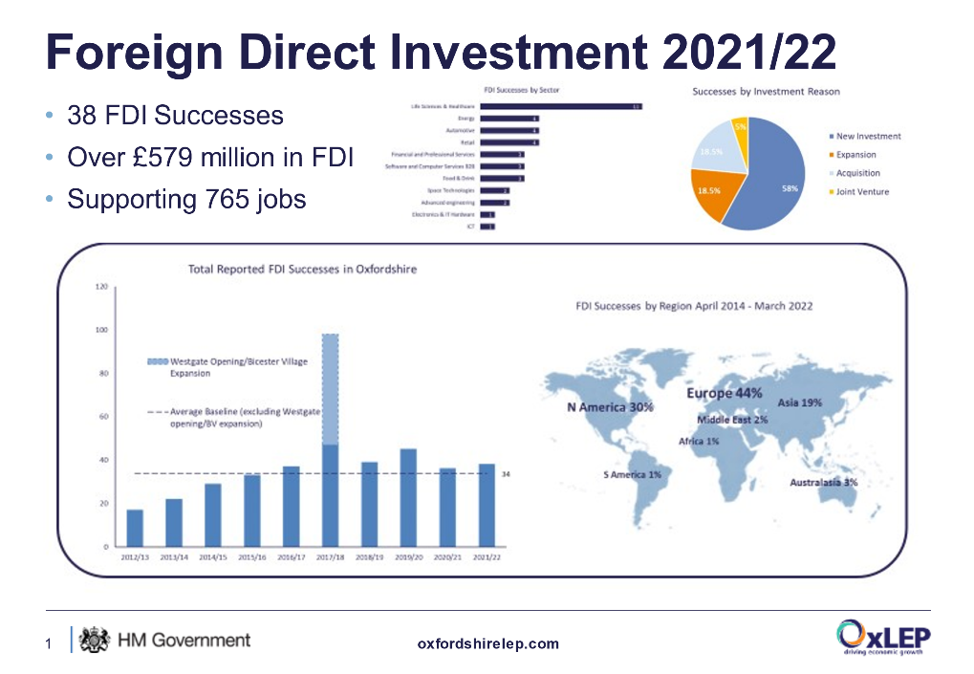

1. Current targets for the last few years have been exceeded and FDI results continue to be strong and illustrate the strength of offer despite the pandemic and EU Exit - over the last five years Oxfordshire has secured over 250 foreign direct investments (FDI) at a value of over £2.3bn, safeguarding and creating over 4500 jobs; many in high value sectors that underpin our science and technology superpower credentials.  However global challenges are likely to result in a potential downturn in the number and value of FDI projects over the next few years.
2. Alongside FDI, we have also seen significant investments into spins outs from the University of Oxford through Oxford Science Enterprises (OSE) who have international investors as shareholders including Google Ventures, Tencent and Fosun and have raised a further £250m in the last year.  OSE has committed £500m to spinout companies, while attracting a further £1bn in co-investment. Oxford and Oxfordshire has also seen capital and real estate investment from Brookfield Asset Management investing into Harwell and Oxford Business Park; and Kadans and Singapore’s GIC investing into Oxford Science Park; Lawrence J. Ellison Institute’s acquisition of property in Oxford for the new Institute for Transformative Medicine; Cadillac Fairview and Stanhope JV with Thomas White Oxford Ltd to deliver the Oxford North development; Columbia Threadneedle’s purchase of New Barclay House in Botley; and Breakthrough Properties’ purchase of Trinity House at Oxford Business Park.
3. OxLEP has co-funded DIT’s Export support programme through an allocation of £120k of ERDF to the Internationalisation Fund.  This was matched by DIT and we subsequently were able to utilise underspend from elsewhere in the programme nationally to support over 30 businesses with c£250k of export support funding helping these SMEs to access news markets across the world including Europe, North America and Asia Pacific.

# Financial implications

1. There are no direct financial implications arising from this report.

# Legal issues

1. The Council works in partnership with the Oxfordshire Local Enterprise Partnership (OxLEP). The OxLEP Board is responsible for approving the overall strategy for the LEP and for agreeing overall priorities for investment. OxLEP is independent of the Council and whilst the Leader of the Council is member of its Board any decisions made by its Board do not bind the Council.

# Level of risk

1. N/A

# Equalities impact

1. N/A

# Conclusion

1. Oxford City Council has an effective partnership with OxLEP’s key staff, teams and Boards. In the last three-years government has made some notable funds available via Local authorities where in the past they might well have been led by LEPs, such as Coronavirus grants, Levelling Up and SPF. It remains to be seen how the future LEP role will evolve alongside that of local authorities, and managing any change well will be important to our success in strategic economic development in future. The current arrangement is directly supporting local business, shaping policy, and earmarking funds for key initiatives in Oxford, albeit at lower levels due to the Levelling Up agenda.

|  |  |
| --- | --- |
| **Report author** | Carolyn Ploszynski |
| Job title | Head of Regeneration & Economy |
| Service area or department | Regeneration & Economy |
| Telephone | 07483 012483 |
| e-mail | cploszynski@oxford.gov.uk |

|  |  |
| --- | --- |
| Background Papers: None | |
| 1 | [OxLEP Annual Report](https://www.oxfordshirelep.com/annualreport20202021) |
| 2. | [Oxfordshire Economic Recovery Plan](https://www.oxfordshirelep.com/sites/default/files/uploads/Oxfordshire%20ERP%20Action%20Plan%20-%20FINAL%20%2826th%20February%202021%29_0.pdf) |
| 3. | [OxLEP Local Skills Report and Plan](https://www.oxfordshirelep.com/skills/our-approach) |
| 4. | [Oxfordshire Industrial Strategy](https://www.oxfordshirelep.com/lis) |
| 5. | [Find your Future Video](https://youtu.be/X1MQlivlOa4) |
| 6. | [Your Fabulous Future Video](https://www.youtube.com/watch?v=i5FcJAfeX) |
| 7. | [Find Your Future Expo](https://the360expo.com/find-your-future) |
| 8. | [Oxfordshire Internationalisation Plan to 2025](https://www.oxfordshirelep.com/sites/default/files/uploads/OxLEP%20Oxfordshire%20Internationalisation%20Plan%201220v3.pdf) |
| 9. | [Gatsby Benchmarks](https://www.gatsby.org.uk/education/focus-areas/good-career-guidance) |